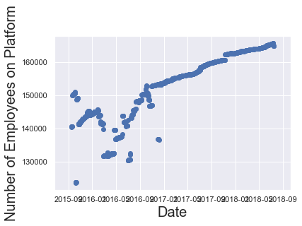

Figure 1: Oracle Employee Trend

Fig.1 talks about the employee change in the company Oracle over time which shows the change of employee numbers suggesting a behaviour movement due to various reasons but when compared to competitors can narrowed down to employee movement to other companies

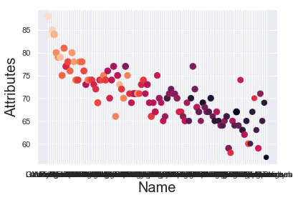

Figure 2: Brazilian Striker Attributes

Fig.2 talks about the first comparison how geographical location can affect attribute development. The attributes compared here are finishing, positioning and reactions.